GREENING OUR CITY – GREEN STREETS
FREQUENTLY ASKED QUESTIONS
What is the "Greening our City — Green Streets” project?
Greening our City – Green Streets is an exciting new project that will see around 1,500 beautiful street trees planted on nature strips along streets, parks and reserves across several suburbs in the east of Penrith.
Greening our City — Green Streets forms a part of Penrith City Council’s Greening our City tree planting program, where we will be planting approximately 5,000 street trees along nature strips across multiple suburbs in the eastern sector of Penrith’s local government area.
The tree planting will improve the look of the streets, making them nicer places to live, walk, and ride.
Research shows that mature street trees improve the values of local properties, and they will help provide shade and cooling from heat in summer. There are many proven health and environmental benefits that can be achieved by planting more trees.
The trees will be planted throughout 2022 and are considered an integral step in Penrith Council’s Cooling the City Strategy to reduce the impact of the urban heat island effect. You can read more about the importance of trees and how they help combat the urban heat island effect in ABC’s 2020 report.
Which suburbs will we be planting in?
The planting will take place in Erskine Park, North St Marys, Oxley Park, St Clair, and St Marys.
Why have these suburbs been chosen for this project?
Community members have often expressed a desire for more vibrant streets and communities. During the development of Council’s Green Grid and Cooling the City strategies, these suburbs were identified as having a vast shortage of trees, providing plenty of opportunities for planting to take place.
The local pride and sense of identity is strong, and it provides a great opportunity to work with the community in improving the local streets.
These areas are also home to many residents who may be vulnerable when exposed to periods of extreme heat, and when the trees are mature, they will help reduce temperatures in summer.
Does this include my street?
We have included maps on the Your Say page for each suburb.
Council has identified potential tree planting sites in these suburbs. We will be sending out letters to residents in these streets to inform them about the tree planting and opportunities to be involved and excluded from the program.
I recently received a letter from Council with information about the tree they want to plant on my nature strip. Does this mean I will be getting a tree?
We will be sending letters to residents living at properties that have been identified as possible sites for the tree planting program. Contractors working on behalf of Council will then assess the site in more detail to determine if it is suitable for planting.
If you receive a letter, it means that your property’s nature strip has been identified as a potential planting site. You can request a change of tree species, an additional tree, or opt out of the program entirely at the Your Say page.
I am included in one of the project areas. Can I also order an additional plant for my private property?
Planting on private is encouraged. We have secured a selection of 200 plants to give away to residents who wish to green their private property through our Plant Deliver-E program.
All you have to do is register your interest and leave your details at the Your Say page.
What species of trees will be planted and how were they chosen?
A range of different tree species will be planted throughout the selected streets.
The tree species have been carefully selected by Council’s landscape architects. Each site will be matched to the most appropriate tree species, taking into consideration:
- Overhead powerlines
- Underground utilities
- Line of sight for residents to see traffic on the road
- Existing trees within the street so the new trees will be consistent with the appearance of the street.
The species chosen are a mix of native and exotic species, and all are suited to our local environment to give them the best chance of thriving. Many of the trees also have either colourful foliage or flowers to make them visually appealing.
Information on each of these species is available on the Greening our City Your Say page.
I don’t want to have a tree in front of my house. Can I opt-out or have the tree moved?
We understand that some residents may have concerns about having access for caravans and boats. We are happy to work with you to ensure the tree planted on the nature strip outside your property is in a location that is convenient to you.
The nature strip is communal land, and while residents undertake basic maintenance like mowing, the land is there to benefit the broader community. Careful consideration during the planning stages helped to determine which tree will be best suited to each location, as outlined in the project map to achieve an optimal outcome for all.
If you would like to opt-out or enquire about an alternative species for your property, please contact Council on 4732 7777 or email SustainabilityTeam@penrith.city. Alternatively, you can complete the online change request or opt-out form.
When will the trees be planted?
Planting has already commenced at numerous parks within the selected suburbs.
Planting in residential streets is scheduled to begin in March 2022 by a contractor working on behalf of Council.
Households with a tree being planted on their nature strip will receive a letter with information about the tree and how to contact Council should you have any questions or concerns.
How will the tree be planted?
The holes for the trees will be dug by the contractor working on behalf of Council. The trees being planted will be similar in size to those planted in our St Marys 2019 pilot project. In March 2022, we began tree planting in Erskine Park (pictured below).
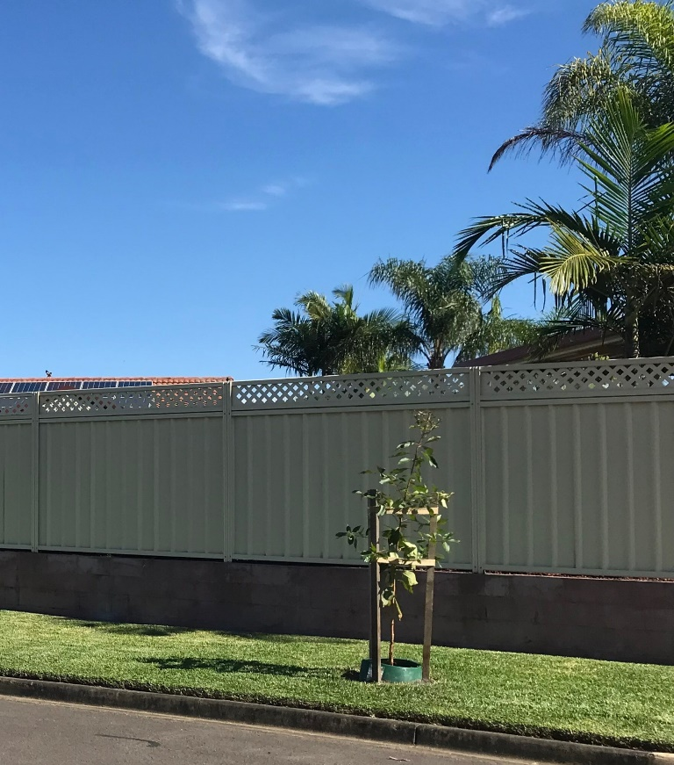
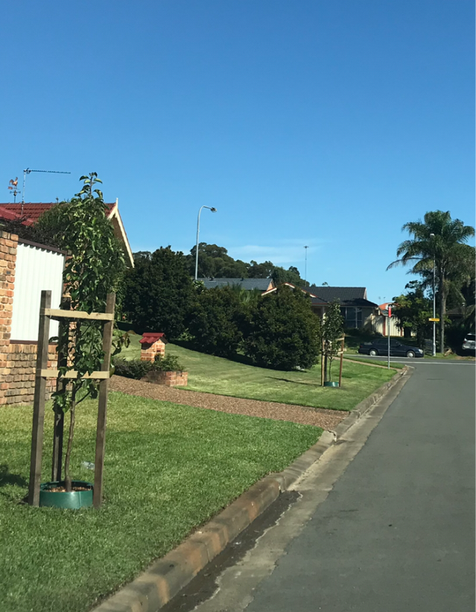
For those who prefer gardening terms, most trees will be 25 or 45 litres in size – this refers to the size of the pot the tree comes in. The bases of the trees will be fitted with a Waterwell collar and mulched. The collar will assist in reducing weed growth around the tree and provide a clean edge for you to mow up to. The trees will be supported with timber stakes.
Image: Trees recently planted in Erskine Park as part of the Green Streets project, April 2022.
Who is responsible for the maintenance of the trees?
We have a developed a tree maintenance program that our contractor will oversee for the first 12 months post-planting. This will provide adequate time for the roots of the tree to establish and allow the tree to thrive without the need for close maintenance.
We greatly encourage residents to water trees close to their property once a month during summer to help the tree grow to its full potential.
Why is Council planting trees to ‘cool the City’ now?
Council is planting trees as part of its long-term Cooling the City Strategy, which identifies the various benefits of planting trees in our City.
Planting trees makes our streets more beautiful and creates a climate that supports a healthy lifestyle. The sooner we plant trees, the sooner they can establish and provide benefits for the community.
Planting in the current weather conditions is beneficial as the trees are less likely to feel stressed by elements like extreme heat. Additionally, any rainfall means that we do not need to rely solely on the city’s water supply for the maintenance of the trees during their establishment.
I’m worried about the challenges of maintaining a tree in front of my house.
The trees that will be planted will take a few years to reach full maturity and size. The tree species have also been carefully selected to minimise any issues associated with maintenance and negative impacts on residents. Apart from your existing nature strip maintenance like mowing, you are not required to undertake any additional work.
Each tree planted in front of a residential property will be fitted with a Waterwell plant collar and filled with mulch. These collars help to make sure that the trees are easy to maintain. Residents will be able to mow their lawns up to the Waterwell collar without concern for damaging the base of the tree.
Will street trees impact the value of my home?
Green and leafy streets are certainly a desirable quality for those in the property market. Australian-based research has shown that increasing tree canopy cover increases property values. According to AECOM’s report on green infrastructure, Sydney suburbs that increased their canopy by 10% saw an average increase in property value of $50,000.
I’m worried about parking my car under the trees.
This project is being undertaken to create more beautiful streets and a more liveable neighbourhood for the greater community. The trees will provide ample shade which can help keep your car cool on hot summer days.
I have allergies/ hayfever – has this been considered?
In selecting tree species to be planted, special consideration was undertaken by our landscape architects to select species suitable to plant in suburban areas, including species least likely to cause allergies.
If you have a specific concern, Council staff would be happy to address those with you personally. Simply contact council on 4732 7777 or email SustainabilityTeam@perith.city
Will the trees impact future footpaths or driveways?
The aim is to minimise future conflict between the trees and accessibility infrastructure in the public space. Council has implemented processes to identify to the best of its ability the most appropriate locations and suitable species size to reduce conflict with existing services and infrastructure.
The contractors working on site will not plant a tree at any site that is determined unsuitable following further on the ground assessments.
Can I choose which species of tree is planted outside my house?
A broad range of tree species have been selected to be planted throughout the streets by Council’s landscape architects. These trees are suitable for their location and take into consideration challenges like overhead powerlines and aesthetically tie in with the existing look of the street and maximise the benefits of using natural resources to heat/cool the home i.e., selecting deciduous or evergreen trees.
If you wish to change the tree species planted at the front of your property, you can let us know via the change species type online form. Council has a small range of tree species available for selection that we have identified are suitable for the area and change in species/ additional tree requests will be subject to stock availability.
If you wish to plant a tree that isn’t in our selected species, we encourage residents to plant a tree of your choosing in your yard to compliment your home.
I looked online and the tree is going to get much bigger than what you say it will.
The landscape architects selecting the tree species have carefully considered a range of factors in determining which trees species to plant. This has also taken into consideration our local climate and soil conditions.
You may find information on your tree species online that says the tree will grow much larger than what Council is saying – that would be under ideal growing conditions in their natural environment.
How do I find out more about the project?
You can learn more about the project and stay up to date is on Council’s Your Say website.
How can I contact Council about the project?
We would love to talk to you about this project and answer your questions and listen to any concerns. You can contact the project team via email sustainabilityteam@penrith.city or phone 4732 7777.

